JAVASCRIPT LAB
PRACTICAL No. 12
Name:
PRN:
File Path:
Aim
To build an interactive, real-time web app using JavaScript and jQuery that uses the DOM, events, web storage and AJAX.
Theory
jQuery is a JavaScript library that makes it shorter to select elements, handle events, change the page and send AJAX requests. AJAX asks the server for data in the background, so the page updates without reloading.
Concept | How it is used in the Live Task Board
DOM | Task rows are built with $("<li>") and .append(); counts and progress bar are updated
Events | One delegated .on("click") on the list; dblclick to edit; form submit; keydown
Storage | Tasks and theme in localStorage; half-typed task and filter in sessionStorage
AJAX | $.getJSON() and $.ajax() with .done() and .fail(); a live feed polled every 10 s
Real time | Live clock, feed polling, and other-tab updates through the storage event

File | Purpose
index.html | Page layout: form, search, filter tabs, task list and side cards
style.css | Blue and coral theme, dark mode and responsive layout
script.js | All the jQuery code
data/*.json | Starter tasks and the live feed (read with AJAX)
jquery.min.js | jQuery 3.7.1 stored locally
Procedure
- Create the page with a form, search box, filter tabs and an empty <ul> for the tasks.
- Write render() to rebuild the list with $("<li>") and update the counts and progress bar.
- Add events: one delegated handler on the list (tick, delete, double-click edit), plus submit and search.
- Save tasks and theme in localStorage; save the draft and active filter in sessionStorage.
- Load data with $.getJSON() and $.ajax(), and poll the feed every 10 seconds with setInterval().
- Listen for the storage event so other open tabs update; run the page with Live Server.
Key Code
// one listener handles every row (event delegation)
$("#taskList").on("click", ".del", function () {
const id = $(this).closest("li").data("id");
tasks = tasks.filter(t => t.id !== id);
localStorage.setItem("ltb_tasks", JSON.stringify(tasks));
render();
});

// AJAX: load starter tasks from a JSON file
$.getJSON("data/tasks.json").done(data => addMany(data.tasks)).fail(onFail);

Output
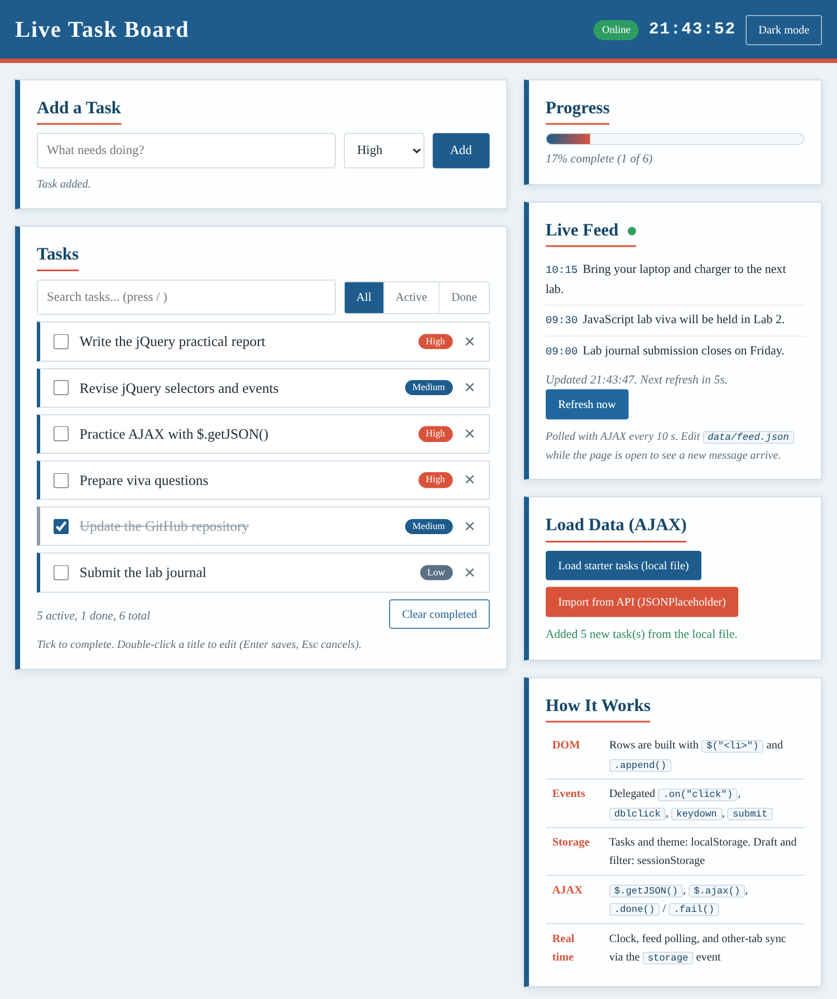  Fig. 1: Light theme, starter tasks loaded with AJAX | 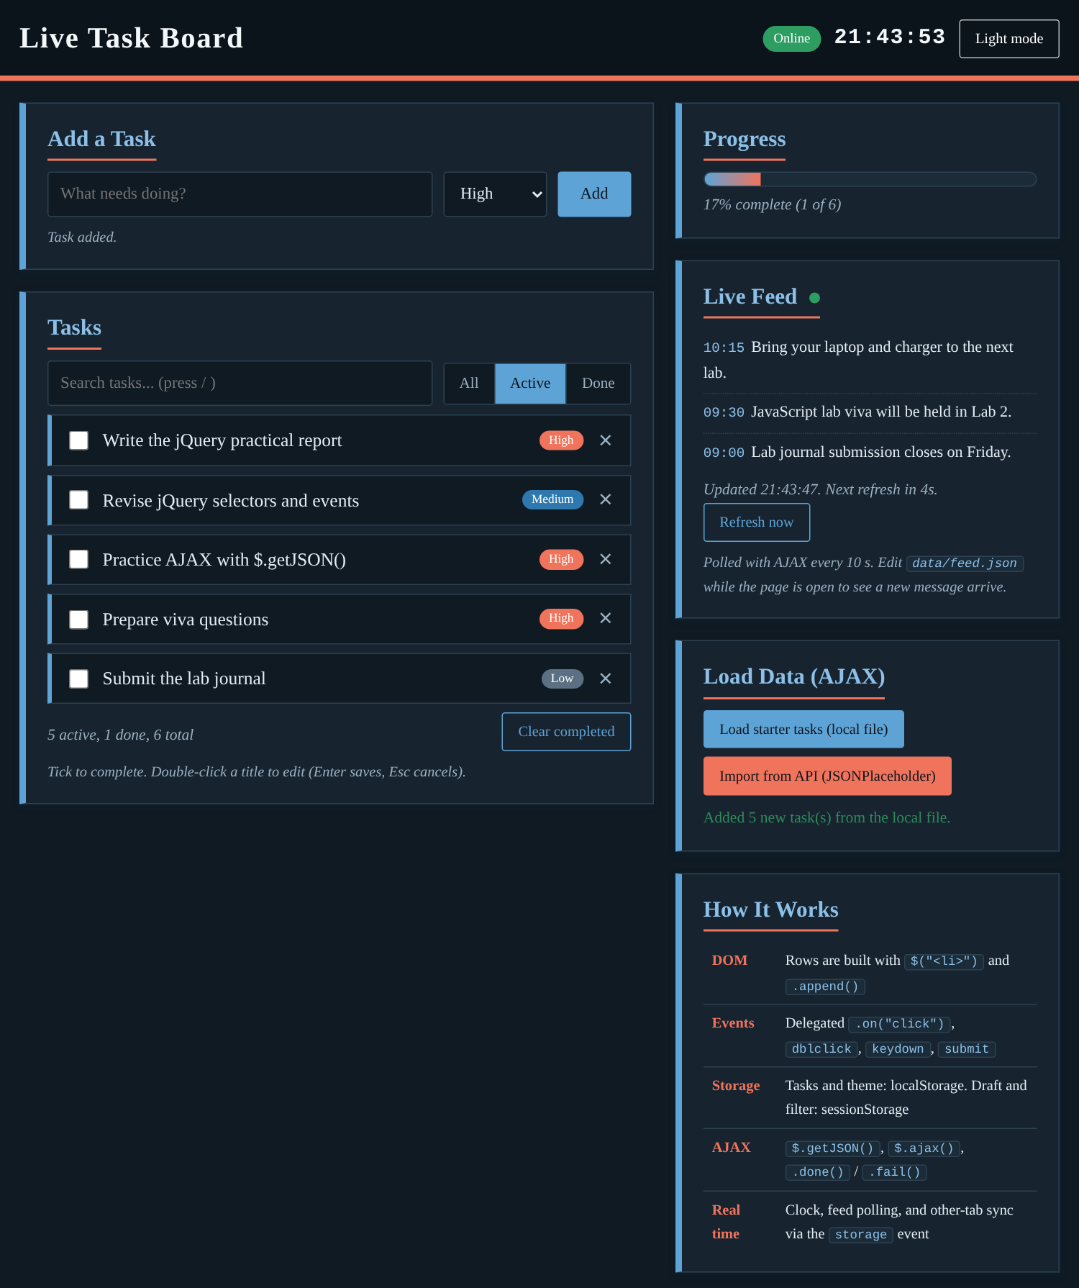  Fig. 2: Dark theme, Active filter selected

Test | Observed result
Add, edit and delete tasks | All worked; Enter saves an edit and Esc cancels it
Refresh the page | Tasks, theme and the half-typed task were restored
Load starter tasks ($.getJSON) | 5 tasks added; a second click added none
Live feed (AJAX polling) | A new message in feed.json appeared with an alert
Second browser tab | A task added in one tab showed in the other at once
Phone width (390 px) | One column, no sideways page scroll
Conclusion
The app combined all four ideas. jQuery built and updated the DOM, and one delegated handler served every task row. localStorage kept the tasks and theme between visits, while sessionStorage held short-lived data such as the draft and filter. AJAX loaded data and refreshed the feed without reloading the page, and the storage event and polling kept the app up to date in real time.

